Today I made a few modifications to the rev. 3 filter that was discussed in the last document and measured the response on the VNA in the LID lab. My intentions were to improve two areas of the filter based on previous measurements. First, I hoped to move our signal of interest to the center of the pass band. Second, I hoped to improve the s11 response of the filter, and hence, improve the impedance match.

To improve the center frequency of the filter, I decided to increase the inductor, L1, in the elliptical section of the filter and measure the change in response. First, I tried increasing the inductor from 15nH to 16nH, which is a fairly modest increase. Here, little change was observed on the VNA. Of note, the inductors that we are using have a 5% tolerance, and therefore, the 1nH change was not significant enough to make a noticeable difference. I next tried an 18nH inductor. Here I could see some shift in frequency, but the second harmonic was no longer properly attenuated. I ended up replacing the 15nH inductor, as this exercise was looking unsatisfying.

I next removed the 15pF capacitor located at the beginning of the elliptical filter. I had noticed in simulation that varying this resistor over a small range had absolutely no effect on the “dip” created by the elliptical filter that we are using to attenuate the 2nd harmonic. I decided to use this cap to tune the impedance of the filter. In simulation, 12pF seemed to work really well, so this is the value I choose. To my satisfaction, the change in capacitance not only improved the impedance of the filter, it also centered the 436.5 MHz signal more in the pass band.

Below is an image of the response of the filter after this modification. The s11 parameter has improved to -22dB and the s21 parameter is less than a dB down. A quick, back-of-the-naplin calculation shows that the filter is passing about 90% of the signal.

Image 1. Response of rev. 4 filter after capacitor change

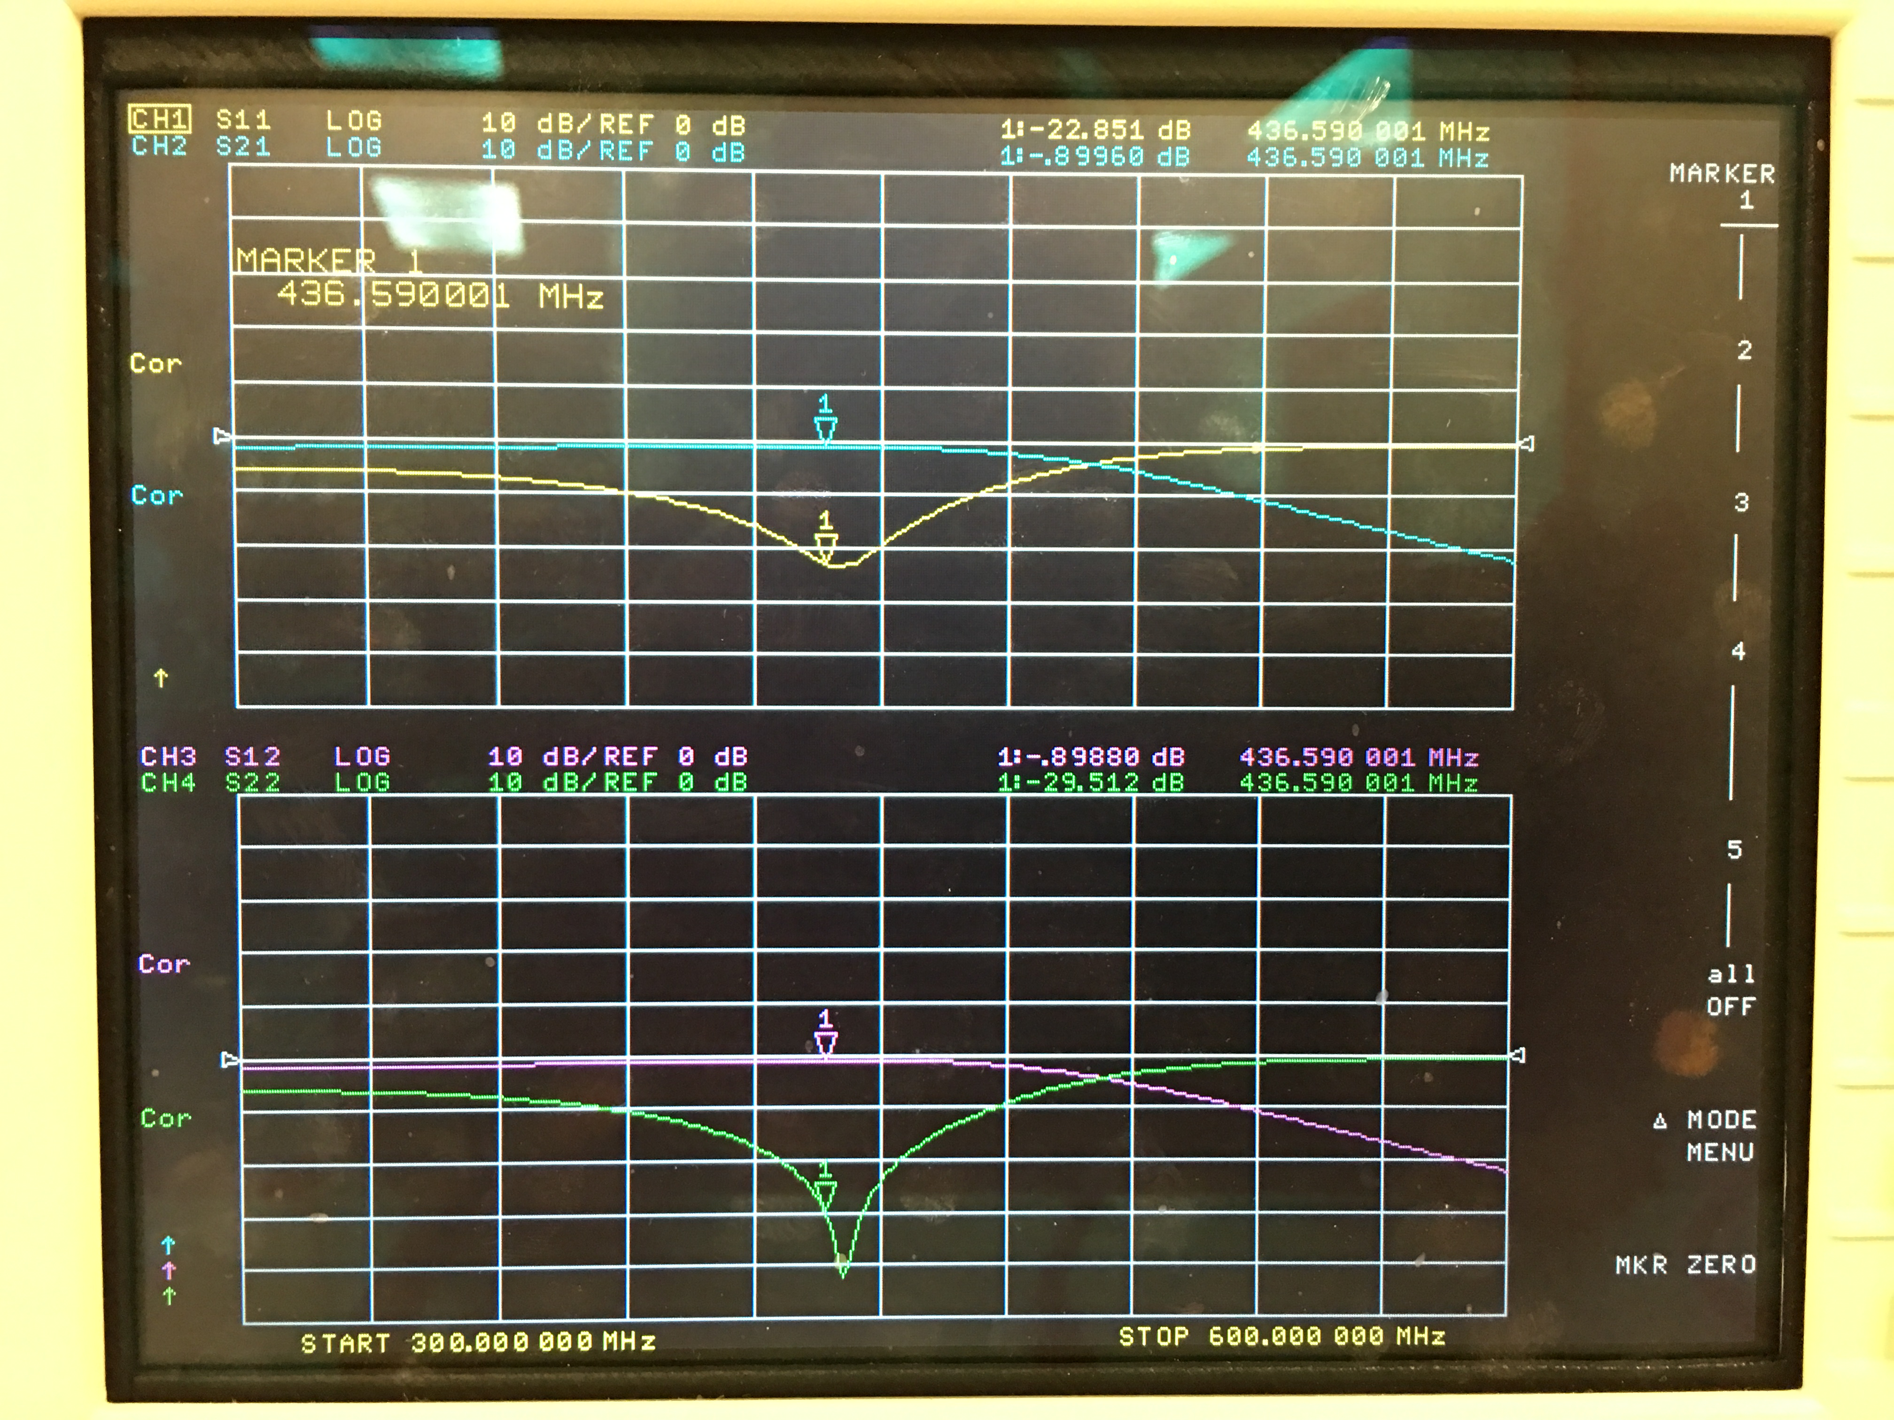

The following image shows the attenuation of the second harmonic. Here, we wish to attenuate -40dB down, and indeed, we are getting around -42 dB at the required frequency.

Image 2 . Response of rev. 4 filter after capacitor change showing pass band and 2nd harmonic

